|  |
| --- |
| **PROJECT PLANNING & MANAGEMENT FORM**  **CMSE 405**  **PROJECT NO: N/A**  **PROJECT NAME:** AI-Powered Minimalist Interior Redesign  **PROJECT START DATE:** 13/10/2025  **PROJECT END DATE:** 27/06/2026  **SUPERVISOR:** Prof. Dr. Hakan Altınçay  **SEMESTER TERM: 2025-26 Fall**  Project Type: Software Design & Development Project  Template updated: 27.02.2023 |

A.1. Preliminary Project Information

# A.1.1

|  |  |
| --- | --- |
| **Project No** | N/A |
| **Project Name** | AI-Powered Minimalist Interior Design |
| **Start Date** | 13/10/2025 |
| **End Date** | 27/06/2026 |
| **Time** | 9 months |

# A.1.2

|  |  |  |  |
| --- | --- | --- | --- |
| **Project Manager** | | | |
| **Name Surname** | Mohamed Elfaki | **ID No** | 22900158 |
| **Title/Role** | Team Leader | | |
| **Address** | Salamis Road | | |
| **Phone** | +90 548 866 59 45 | | |
| **Email** | [Moh.omer24@gmail.com](mailto:Moh.omer24@gmail.com) | | |

A.2 Group Information

# A.2.1

|  |  |  |  |
| --- | --- | --- | --- |
| **Student 1** | | | |
| **Name Surname** | Saad Ahmed | **ID No** | 22701636 |
| **Title/Role** | Full Stack Developer | | |
| **Address** | Famagusta, Salamis Road | | |
| **Phone** | +90 548 866 90 12 | | |
| **Email** | saadtaqi2004@gmail.com | | |

|  |  |  |  |
| --- | --- | --- | --- |
| **Student 2** | | | |
| **Name Surname** | Firas Abdelgadir | **ID No** | 22703822 |
| **Title/Role** | Lead Backend Developer | | |
| **Address** | Gazimagusa, Kaliland | | |
| **Phone** | + 90 548 866 9200 | | |
| **Email** | firasnazar@gmail.com | | |

|  |  |  |  |
| --- | --- | --- | --- |
| **Student 3** | | | |
| **Name Surname** | Ahmed Salmi | **ID No** | 22703233 |
| **Title/Role** | Lead AI engineer | | |
| **Address** | Famagusta | | |
| **Phone** | +971 568311359 | | |
| **Email** | [Ahmedmhjoob10@gmail.com](mailto:Ahmedmhjoob10@gmail.com) | | |

# A.2.2

|  |
| --- |
| **List of Completed / Ongoing Projects of Team** |
| FarmCast  NeuroLearn  StrayAway |

B.1 Introduction to Project

# B.1.1

|  |
| --- |
| **Summary of Project** |
| Declutter is a web/mobile application that redesigns room interiors into a minimalist form. Using computer vision and deep learning, the system analyses room images. It generates simplified photos with minimalist furniture designs and neutral colour palettes that are easy on the eye. It also generates other designs for the room. The app allows users to upload their room photos and receive AI-generated redesign arrangements. In addition, budget aware recommendations, and room analysis. |

# B.1.2

|  |
| --- |
| **Key Words** |
| Computer Vision, YOLO, GANs, Python, Flask, React, Room Redesign, Mask R-CNN |

# B.1.3

|  |
| --- |
| Aim of Project |
| The aim of this project is to design and develop an AI-powered web/mobile application that renovates interior spaces into their minimalistic form. It transforms living spaces into functional, clean, and visually balanced images through deep learning and computer vision. The web/mobile application will redesign rooms for non-professionals by analysing their uploaded photos. Declutter gives personalized layout suggestions and budget-friendly recommendations that align with the user's needs and style, making interior redesign accessible and affordable enough for most users. |

# B.1.4

|  |
| --- |
| **Innovative Aspects/Contributions of Project** |
| Declutter offers a comprehensive solution for interior redesign. Transforming images into minimalist, modern or other layouts. It stands out by giving personalized, budget-aware redesign suggestions without the need of professional assistance. The app is user-centred and highly values both expert and customer feedback. |

# B.1.5

|  |
| --- |
| **Methods to be Applied** |
| Declutter will use a combination of computer vision and generative deep learning models. Specifically, object detection models including YOLOv8 and Mask R-CNN to identify and segment elements of the room such as walls, furniture, decoration. Generative adversarial networks, trained on data obtained regarding different styles of room design will generate the new designs including minimalist style. The frontend will be built on React for clear separation of concerns and connected to the backend, which will subsequently be built using Python on top of Flask. |

# B.1.6

|  |
| --- |
| **Economic and National Outcomes** |
| This project will support the interior design and the architectural industry, give preliminary redesign ideas and minimize the cost of professional consultations. It also serves as a preview to clients, ensuring satisfaction with the style before starting the building process. Declutter provides AI support in the design sector, reducing time taken by professionals to do the same work. |

B.2 Reason of Starting the Project, Methods and R&D Stages

# B.2.1

|  |
| --- |
| **1- Explain the reason of starting this project. (Max 500 character)** |
| We initiated this project after identifying a gap in the market for accessible, AI-driven interior design tools. Many users find hiring architects time-consuming and costly, so our solution provides a faster, simpler, and more affordable way for anyone to redesign their living spaces effortlessly using AI assistance. |

|  |
| --- |
| **2- Explain the purpose of this project.** |
| The purpose of this project is to design and develop an AI-powered web/mobile application that will renovate interior spaces into their minimalistic form. It transforms living spaces into functional, clean, and visually balanced images through deep learning and computer vision. The web/mobile application is going to redesign rooms for non-professionals. Declutter gives users personalized layout suggestions and budget-friendly recommendations that align with the user's needs and style, making interior redesign more accessible and affordable for users. |
| **3- Explain**   * **output of project** * **national / international standards if exist** * **the specific objectives of the project** * **success criteria's** * **realistic constraints** |
| 1: The output of this project is a fully working mobile app and a web page powered by AI which takes pictures as inputs and gives a minimalist design as an output which the user can analyse and change according to their needs.  2: National / International Standards (If exist)  This project aligns with various industry and security standards, including:  IEEE 830-1998 – Software Requirements Specification Standard  ISO/IEC 27001 – Security and Data Protection Standard  GDPR Compliance— Ensures protection of personal user data (for potential international use)  3: Specific Objectives of the Project  Fully working mobile app and a webpage. Trained AI capable of giving actual useful outputs  4: Success Criteria  The mobile app and web page should be user-friendly.  User authentication should work.  The search system response should be less than 2 seconds.  The mobile app should be capable of holding 5000 users concurrently.  The first month, the app should have 10,000 users.  5: Realistic Constraints  Limited time; less than 3 months for project completion.  Small team; 4 total members  Limited resources; 4 laptops computational power |
| **4- Explain**   * **the methods to be applied during R&D activities** * **applications** * **technics and tools to be used** * **standards to be followed under the workflow** |
| For this project, we have decided to rely on Evolutionary Development for our software process model, particularly Agile Software Mode, as it will help us develop the system in incremental phases, test them regularly, and adjust according to user feedback. Since AI-based projects require constant experimentation, model fine-tuning, and iterative improvements to achieve the desired optimality in performance, the Agile Model allows us the flexibility required to complete this project.  **Explain, Project Workflow:**   1. **Feasibility and Pre-research:**      * Define the project’s aim and expected results. * Identify suitable datasets to be used * Identify the required amount of raw data to fine tune the models  1. **System Design:**  * Create Figma designs for web and mobile UIs * Decide on database schema and designs * Dataset preparation  1. **Software development:**  * Implement backend logic * Fine tune the models on the optimized data sets * Implement the database  1. **Prototype implementation and testing work:**  * Further testing on model accuracy against test datasets * Developing MVPs for web and mobile applications * Deploying beta versions of the system  1. **Maintenance:**  * Get feedback from users on beta system performance   Explore potential ways to increase model accuracy |
| **5- Explain**   * **the contribution of national/international technological development if exist** * **starting a new research and development projects within or outside the team** * **launch new applications or research studies in different technology areas**   **With whom we can cooperate?**  **Expectations:**  **Published work:**  **Can your output be an input for other similar national/international projects?** |
| * Declutter will contribute to international technological development by pushing for the inclusion of AI technology in architecture and interior design * Our work in Declutter can easily be extended to other R&D projects in similar fields. The knowledge we gain from developing the interior design system can be manipulated and extended in the development of an exterior design system, renovation cost estimation system, or even a smart home design system. * Furthermore, similar models to the ones we fine-tuned during our implementation stages could also be used for research and development stages for other areas of interest, like AI visualization projects, such as generative art creation, AI-driven furniture recommendation system, or real-time AR/VR room staging applications. * Architectural firms will be one of the main groups we’ll cooperate with in our project, to get an idea of the inner functionality of an interior design system like ours, and what is generally expected from it. We can also cooperate with online design platforms that may be interested in integrating AI-powered redesign into their systems. * Given that our project reaches an acceptable success rate in the future, we expect to release our system as an open-source repository to GitHub to allow for developer collaboration. * Our completed work can without a doubt be used as input for other similar projects, as the potential teams that will be using our project as reference can make use of the optimized data sets and the fine-tuned models. |

B.3 Innovative and Unique Aspects

# B.3.1

|  |
| --- |
| **1- Describe**   * **differences** * **advantages** * **superiority**   **compared to other similar projects.** |
| Other projects similar to this exist, namely, ReRoom. DeClutter and ReRoom both use AI to transform room images into different interior styles, such as minimalist, classic and modern. ReRoom has a closed source, in contrast, our application DeClutter has an open-source code, open for all to use free of charge. |

# B.4.1

|  |
| --- |
| **2- Who can contribute to this project in your team?** |
| * Project manager * System analyst * Programmers * System Designer * User interface designer * Database developer * Tester |

C.1 Gantt Chart and Work Packages

|  |
| --- |
|  |

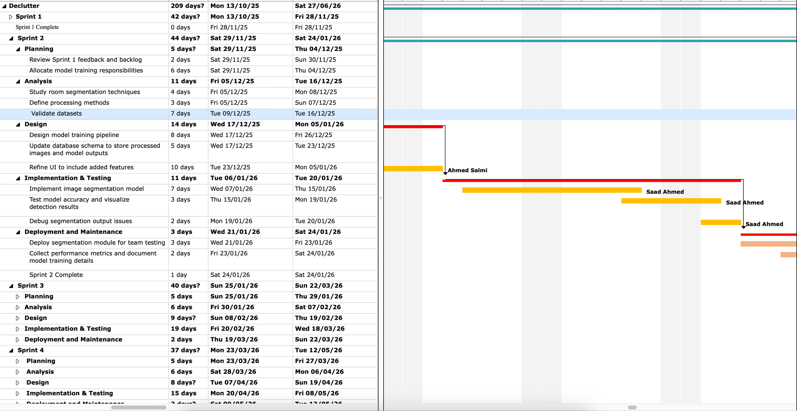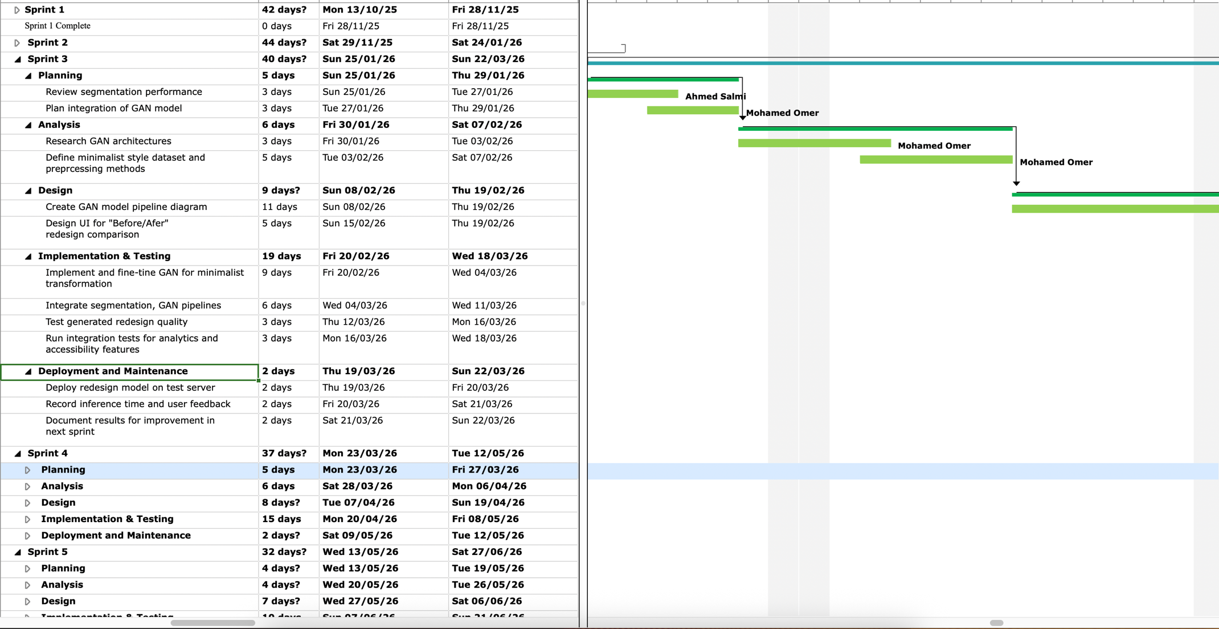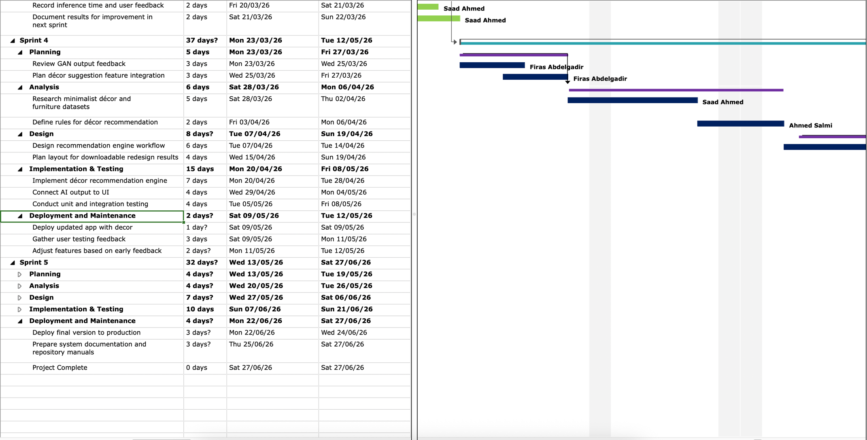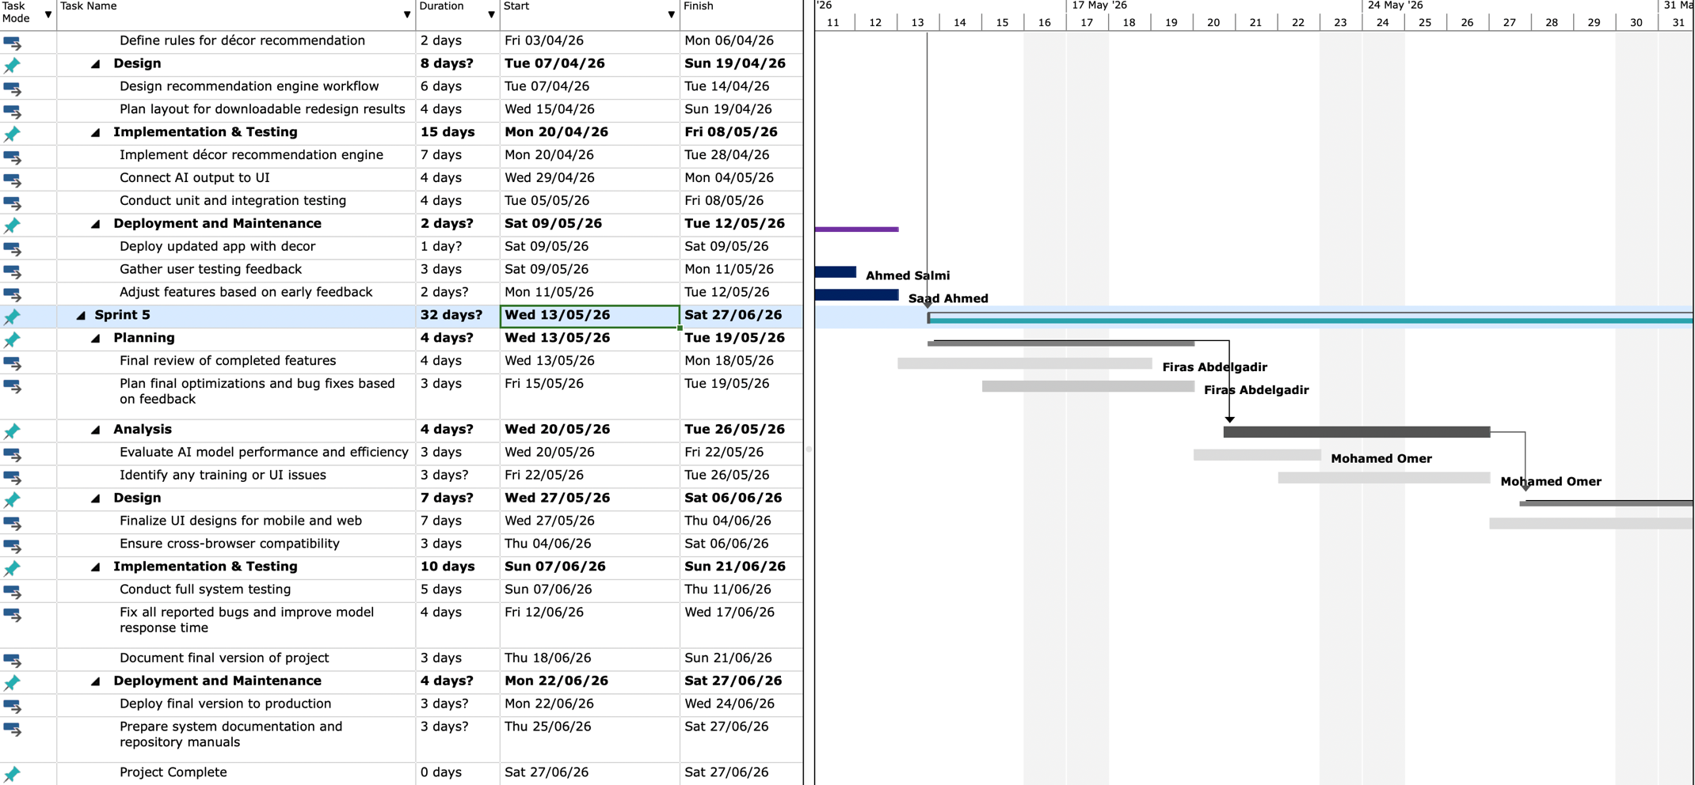

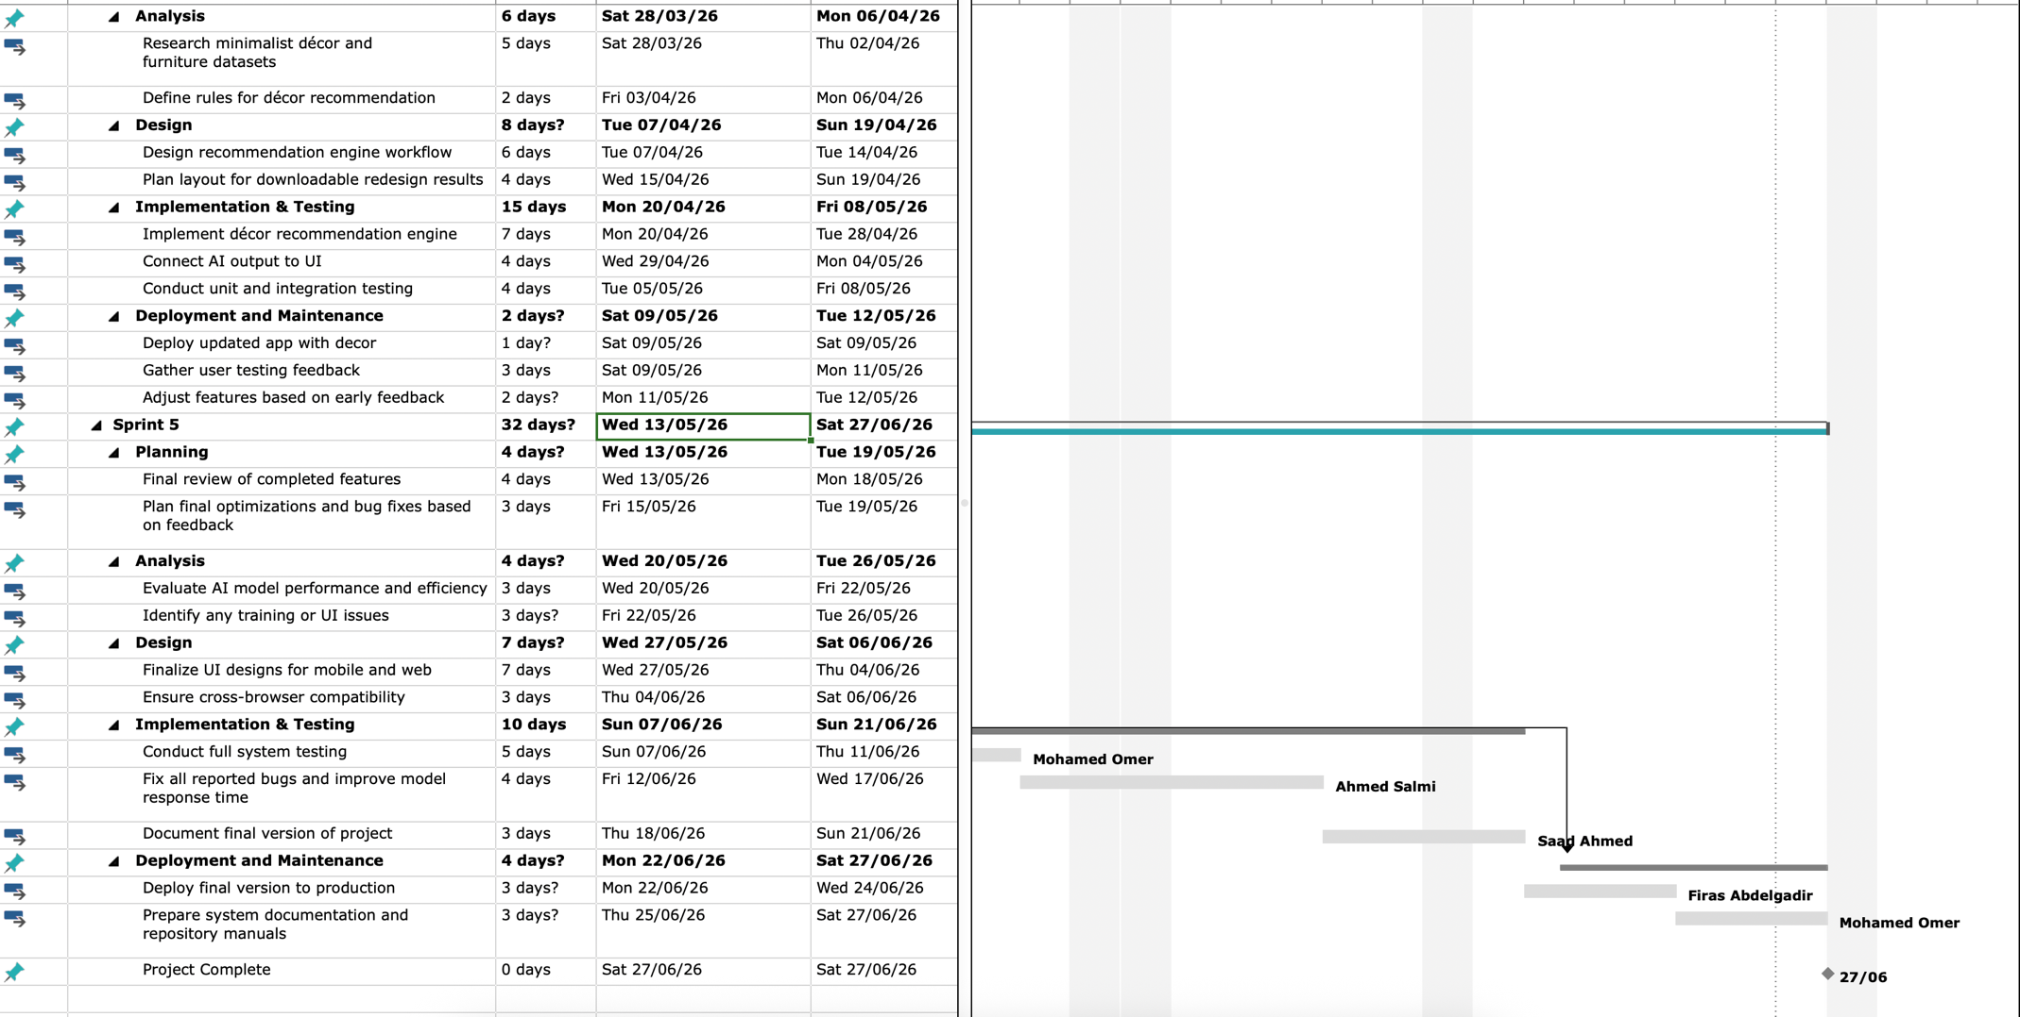

# C.1.2 List of Work Packages

|  |  |
| --- | --- |
| **Work Package No** | 1 |
| **Work Package Name** | **Sprint 1** |
| **Start-End Date and Time** | 13/10/2025 - 28/11/2025 |
| **Related Organizations** |  |
| **1- List the activities of work packages.** | |
| **1.1 Project Process and Economic Feasibility:**  1.) Planning  - Project Initiation  - Define Project Scope  - Identify key AI-driven features  - Assign team roles and set up development environments  - Economic feasibility studies:    2.) Analysis  - Conduct market research on similar systems  - Define most essential user requirements  - Identify datasets to be used  - Specify hardware/software needs  - Conduct Risk Analysis    3.) Design  - Create UI design mock-ups  - Designing system diagrams  - Design system architecture and database schema    4.) Implementation & Testing  - Setting up project repository  - Implement simple web interface  - Test image upload functionality   * Verify backend connectivity   5.) Deployment & Maintenance   * Deploy early prototype to test environment * Gather feedback from team members * Document findings for Sprint 2   **1.2 Technological Feasibility:**   * Modern AI and machine learning technologies have the capacity to complete this project’s objectives * Room segmentation can be done by deep learning models such as Mask R-CNN, YOLO and U-net * Generative Adversarial Networks (GANs) - such as Pix2Pix, CycleGAN, and StyleGAN – can handle image generation. * Cloud platforms like AWS, or Azure ML can be used for model training and deployment * All in all, the project is technologically feasible with the current advancements in the machine learning field | |
| **2- Describe the methods and parameters that will be used for the work package.** | |
| During Sprint 1, the main focus will be to define in clear terms the direction we want to take with this project, the expectations of the final product, and the system requirements required to satisfy those expectations. We will set up the project and development environments, identity the datasets to be used in the training stages, research similar projects for more ideas. | |
| **3- List the experiments, tests, and analysis in the work package.** | |
| * Feasibility tests (Economic and Technological) * Requirement Gathering & Validation * Risk & Security Analysis * Dataset evaluation | |
| **4- List the output of work package and its success criteria.** | |
| **Outputs:**   * Feasibility Study Reports * Initial Requirements Document * First UI Designs * Completed Authentication System * Risk Analysis Report * List of datasets to be used * List of similar projects   **Success Criteria:**   * Economic feasibility is justified if the project costs stay within the projected budget constraints * Technological feasibility is justified if a practical AI model and database infrastructure are selected * Risk Assessment is completed if 3 significant risks are found, and mitigation plans for each of them are prepared | |
| **5- Explain the relation of output with other work packages** | |
| * Database schema and architectural design will be used in the implementation stages of future sprints * The UI drafts will be used as reference in future sprints * Feasibility study will decide whether adjustments are needed in future sprints in the selection of the techs stack * Risk Analysis report will also be built upon to plan secure data handling policies for future sprints | |

|  |  |
| --- | --- |
| **Work Package No** | **2** |
| **Work Package Name** | **Sprint 2** |
| **Start-End Date and Time** | **29/11/2025 - 24/01/2026** |
| **Related Organizations** |  |

|  |
| --- |
| **1- List the activities of work packages.** |
| **1.) Planning**   * Review Sprint 1 results * Allocated model training responsibilities   2.) Analysis   * Study room segmentation techniques (YOLO, Mask R-CNN) * Define preprocessing methods * Prepare dataset splits for training/validation   3.) Design   * Design model training pipeline * Update database schema to store processed images and model outputs   4.) Implementation & Testing   * Implement image segmentation model * Test model accuracy and visualize detection results * Debug segmentation output issues   5.) Deployment & Maintenance   * Deploy segmentation module for team testing * Collect performance metrics * Document model training details |
| **2- Describe the methods and parameters that will be used for work package.** |
| * Comparative analysis * Dataset preprocessing * Dataset splitting into training, validation and testing sets * Version control used to monitor model iterations |
| **3- List the experiments, tests and analysis in the work package.** |
| * Train and compare multiple segmentation models * Data augmentation analysis * Accuracy and performance evaluation * Visual output analysis |
| **4- List the output of work package and its success criterias.** |
| **Outputs:**   * Fine-tuned and validated room segmentation model * Processed dataset * Visual results   **Success Criteria:**   * Segmentation accuracy reaches at least 75% on validation data * Image processing takes no longer than 15 seconds * Model can clearly differentiate major room elements * Deployment of segmentation module in isolated testing environment |
| **5- Explain the relation of output with other work packages** |
| * Segmentation model, which is essential particularly for Sprint 4, where style transfer and minimalist redesign generation * Processed dataset will be used for further fine-tuning in future sprints |

|  |  |
| --- | --- |
| **Work Package No** | **3** |
| **Work Package Name** | **Sprint 3** |
| **Start-End Date and Time** | **25/01/2026 - 22/03/2026** |
| **Related Organizations** |  |
| **1- List the activities of work packages.** | |
| **1.) Planning**   * Review segmentation performance * Plan integration of style transfer (GAN) model   2.) Analysis   * Research GAN architectures * Define minimalist style dataset and preprocessing methods   3.) Design   * Create GAN model pipeline diagram * Design UI for redesign comparison   4.) Implementation & Testing   * Implement and fine-tine GAN for minimalist transformation * Integrate segmentation with GAN pipeline * Test the quality of generated redesigns   5.) Deployment & Maintenance   * Deploy redesign model on test server * Record inference time and user feedback | |
| **2- Describe the methods and parameters that will be used for work package.** | |
| * Research different GAN architectures and identify the most suitable one for our system * Model training parameters will be tuned to achieve optimal performance * Visualization tools will be utilized to generate comparisons of the original vs generated images quality assessment * Dataset consisting of real-world room images that were segmented in the previous sprint will be input to the model. | |
| **3- List the experiments, tests and analysis in the work package.** | |
| * Model architecture comparison * Training and fine-tunning tests * GAN performance evaluation * Integration test | |
| **4- List the output of work package and its success criterias.** | |
| **Outputs:**   * Functional style transfer GAN model capable of transforming room photos into minimalist designs. * Integrated pipeline connecting the segmentation module from the previous sprint and the redesign module of this sprint. * UI for visual comparison of original and redesigned images.   **Success Criteria:**   * GAN model achieves at least 80% SSIM (Structural Similarity Index) and decent FID (Fréchet Inception Distance) scores * Regeneration time per image under 30 seconds * Regenerated images clearly display minimalist aesthetics | |
| **5- Explain the relation of output with other work packages** | |
| * Style transfer module developed during this sprint serves as the core of the project * Outputs of this sprint will be used for system testing and enhancements in the future sprints | |

|  |  |
| --- | --- |
| **Work Package No** | **4** |
| **Work Package Name** | **Sprint 4** |
| **Start-End Date and Time** | **23/03/2026 - 12/05/2026** |
| **Related Organizations** |  |
| **1- List the activities of work packages.** | |
| **1.) Planning**   * Review GAN output feedback * Plan integration of decor suggestion feature   2.) Analysis   * Research minimalist decor and furniture datasets * Define rules for decor recommendation   3.) Design   * Design recommendation engine workflow * Design UI for decor recommendation feature   4.) Implementation & Testing   * Implement decor recommendation engine * Display AI output (image regeneration, decor recommendation etc.) on UI * Unit, Integration Testing   5.) Deployment & Maintenance   * Deploy updated app with decor suggestion feature * Record user feedback * Identify potential improvements for final sprint | |
| **2- Describe the methods and parameters that will be used for work package.** | |
| * Dataset for decor and furniture will be used * AI-assisted recommendation algorithm used to match suitable furniture and decor * Testing and evaluation * Natural Language Processing (NLP) may be used for labelling decor recommendations | |
| **3- List the experiments, tests and analysis in the work package.** | |
| * Dataset Evaluation * Testing accuracy of recommendations * UI/UX testing * Performance testing and analysis | |
| **4- List the output of work package and its success criterias.** | |
| **Outputs:**   * Functional style decor recommendation engine integrated with the AI redesign module * UI displaying decor suggestions   **Success Criteria:**   * Decor recommendations align with minimalist design principles * Recommendations shown clearly * Decor suggestion generation time under 20 seconds | |
| **5- Explain the relation of output with other work packages** | |
| * Decor recommendation module builds upon the outputs of the last sprint * Final integration layer * Outputs to be refined in Sprint 5 | |

|  |  |
| --- | --- |
| **Work Package No** | **5** |
| **Work Package Name** | **Sprint 5** |
| **Start-End Date and Time** | **13/05/2026 - 27/06/2026** |
| **Related Organizations** |  |
| **1- List the activities of work packages.** | |
| **1.) Planning**   * Final review of all implemented features * Plan final optimization steps, bug fixes and UI polishing   2.) Analysis   * Evaluate AI model performance and efficiency * Identify any outstanding errors or bugs   3.) Design   * Finalize UI pages * Ensure responsive interface   4.) Implementation & Testing   * Conduct full-system testing * Fix all reported bugs and fine-tune model to improve response time if possible   5.) Deployment & Maintenance   * Deploy final version of system to production * Prepare system documentation * Conduct system presentations/demonstrations | |
| **2- Describe the methods and parameters that will be used for work package.** | |
| * Performance benchmarks * Comprehensive system reviews * Device compatibility testing | |
| **3- List the experiments, tests and analysis in the work package.** | |
| * Full-System Integration Testing * Performance Testing * Stress Testing * Regression Testing * Security Testing | |
| **4- List the output of work package and its success criterias.** | |
| **Outputs:**   * Final version of DeClutter web and mobile applications * Complete system documentation * Deployable and scalable system   **Success Criteria:**   * System passes all tests * Positive feedback from users * Successful deployment | |
| **5- Explain the relation of output with other work packages** | |
| * Culmination of the prior sprints | |

# C.1.3 List of Milestones (should be matched in the Gantt chart)

|  |  |  |
| --- | --- | --- |
|  | Description of Output | Expected Time Interval |
|  |  |  |
| 1 | Sprint 1 | 13/10/2025 - 28/11/2025 |
| 2 | Sprint 2 | 29/11/2025 - 24/01/2026 |
| 3 | Sprint 3 | 25/01/2026 - 22/03/2026 |
| 4 | Sprint 4 | 23/03/2026 - 12/05/2026 |
| 5 | Sprint 5 | 13/05/2026 - 27/06/2026 |

# C.1.4 List of Risks (see example, define other risks of your project!)

|  |  |  |  |
| --- | --- | --- | --- |
| Risk | Probability | Effects | Your Strategy |
| The time required to develop the software is underestimated. | High | Serious | Using agile approach, set aside buffer time and enhance the project management techniques |
| Software tools cannot work together in an integrated way. | High | Tolerable | Middleware development, early compatibility test and well considered tool selection |
| Customers fail to understand the impact of requirements changes. | Moderate | Tolerable | Maintain a clear communication with the customer throughout the project, give detailed documentation and conduct requirement evaluation |
| The rate of defect repair is underestimated. | Moderate | Tolerable | Replace potentially defective components with more reliable bought-in components. |
| The size of the software is underestimated. | High | Serious | Investigate buying SW components.  Investigate use of a program generator. |
| Code generated by code generation tools is inefficient. | Moderate | Insignificant | Add manual coding as needed, optimize the generated code and conduct routine performance reviews |
| Key staff are ill at critical times in the project. | Moderate | Serious | Reorganize team so that there is more overlap of work and people therefore understand each other’s jobs. |
| The database used in the system cannot process as many transactions per second as expected. | Moderate | Serious | Investigate the possibility of buying a higher-performance database. |
| AI generated content may be inaccurate | High | Serious | Fact-checking procedures, establish user feedback and ongoing AI model evaluation |
| High server loads can result the platform to go down | Moderate | Serious | Use scalable cloud infrastructure and load balancing strategies |
| The AI accuracy for analysing the images is lower than expected | High | Tolerable | Fine-tune models more, increase the size of the dataset and validate performance on diverse real-world photos |
| Deployment cost exceeds expectations | Moderate | Tolerable | Use mostly open-source services, track the usage of these services and optimize the backend for efficiency |
| User adoption rate is lower than estimated | Moderate | Serious | Invest more effort on the marketing and gather early feedback from users |
| GDPR compliance and data privacy problems | Moderate | Serious | Ensure compliance with GDPR standards, store and process user data in a secure way that prevents identification of individuals |
| Third party APIs or libraries become unstable | Moderate | Tolerable | Keep the dependencies always updated, apply fallback solutions and check the compatibility regularly |
| Technical failures during deployment | Moderate | Serious | Maintain backups and prepare rollback procedures to restore previous faster |
| Lack of team communication or task coordination | Moderate | Serious | Hold more meetings, use collaboration platforms like Slack assign clear roles and responsibilities for the task |

C.2 Project Management and Organization

# C.2.1 Project Team

|  |  |  |  |  |  |  |
| --- | --- | --- | --- | --- | --- | --- |
| Personnel Name | Title | ID | Education Status | Graduation Date | Date of Starting Work | Idea Owner |
| Mohamed Elfaki | Project Manager | 22900158 | Bachelor’s Student | July 2026 | October 2025 | No |
| Firas Abdelgadir | Lead Backend Engineer | 22703822 | Bachelor’s Student | July 2026 | October 2025 | No |
| Saad Ahmed | Front-end Developer | 22701636 | Bachelor’s Student | July 2026 | October 2025 | No |
| Ahmed Salmi | Lead AI engineer | 22703233 | Bachelor’s Student | July 2026 | October 2025 | No |

# C.2.2 Organization Scheme

D.1 Economic Forecasts

|  |
| --- |
| **1- Evaluate the commercialization potential of project outcomes. List possible risks here?** |
| Declutter has high commercialization potential, particularly, due to its scalability and wide target audience. Some of which include, homeowners, real estate agencies, and decoration retailers. This project can work on both a B2B and B2C basis, servicing both consumers and businesses while providing API licensing. |

|  |  |
| --- | --- |
| **2- List your expectations to your team which are come by your project** | |
| Time-to-market (month): | 10 |
| The expected increase in sales revenue (%): | 20 |
| The expected increase in market share (%): | 10 |
| Time to start to gain: | 6 months |

D.2 National Outcomes

|  |
| --- |
| **1- Specify the output that may be subject to patent, utility model and industrial design registration in the project.** |
| The combination of processes to turn an image of a room from the original to a new design, using computer vision (YOLO, MaskR-CNN) and GANs. These unique combination of processes predict optimal furniture placements and colours and may qualify for software patent, industrial design registration or utility model protection. |
| **2- Explain the potential of project and its outputs that may have an effect on social life, education, health and etc.** |
| This project can make professional redesign accessible to anyone with a smartphone. It can be used by students to study minimalist design principles. In addition, minimalist room designs promote mental clarity and reduce stress, facilitating better living environments. |
| **3- Explain the positive and negative effects of project outputs for environment and human being.** |
| Positive:   * Minimalist and sustainable living is promoted by minimalizing the amount of clutter in the room including unneeded furniture. * Carbon footprint is reduced through optimized allocation of furniture. * Links users to budget friendly eco-friendly options   Negative:   * Computational power required to train the AI * Lowers creative thinking in humans, fully delegating this process to AI |

(M013) Instrument / Equipment / Software / RELEASE PURCHASES

|  |  |  |  |  |  |  |  |  |  |  |  |
| --- | --- | --- | --- | --- | --- | --- | --- | --- | --- | --- | --- |
| **Project Name** | | **AI-Powered Minimalist Interior Redesign** | | | | | | | | | |
| **Line no** | **Instrument / Equipment / Software / Publication Name** | | **No. of Item** | **Capacity** | **Technical specification** | **Purpose of Project Activities** | **Post-Project Place of Use / Purpose** | | **Unit Price (USD)** | **Unit Price (TL)** | **Total Amount (TL)** |
| **R & D** | **Production** |
| **1** | **Laptop** | | **4** |  | **min Intel i5/i7 core, min 100GB Storage** | **Development** | **Yes** |  | **$1,500** | **62,931** | **251,727** |
| **2** | **Internet Connection** | | **4** |  | **High-Speed Internet, min 10Mbps speed** | **Connection** | **Yes** |  | **$40** | **1678** | **80544** |
| **3** | **Visual Studio Code** | | **4** |  | **Coding IDE** | **Coding, Debugging and Testing** |  | **Yes** | **Free** | **Free** | **Free** |
| **4** | **GitHub** | | **1** |  | **Project Sharing** | **Development** | **Yes** |  | **Free** | **Free** | **Free** |
| **5** | **Ms Visio** | | **1** |  | **Chart Design** | **Diagram & Planning** | **Yes** |  | **$10 per user** | **420 / Per User Monthly** | **20,160 / Yearly** |
| **6** | **Server Hosting** | | **1** |  | **AWS** | **Deployment** | **Yes** |  | **$10 per user** | **420 / Per User Monthly** | **20,160 / Yearly** |
| **7** | **Figma** | | **1** |  | **Design Software** | **UI/UX Design** | **Yes** | **Yes** | **Free** | **Free** | **Free** |
| **8** | **PostgreSQL/ MongoDB** | | **1** |  | **Database Management** | **Database** | **Yes** |  | **Free** | **Free** | **Free** |
| **9** | **MS Project Tools** | | **1** |  | **Project Task management software** | **Planning** |  | **Yes** | **Free/ By University** | **Free** | **Free** |
|  |  | |  |  |  |  |  |  |  | **TOTAL** | **372,591 TL** |

(M030) Quarterly Estimated Cost Form (TL)

|  |  |  |  |  |
| --- | --- | --- | --- | --- |
| **Project Name: AI-Powered Minimalist Interior Redesign** | | | | |
| **Cost Item** | **2025-2026** | | **TOTAL**  **(TL)** | **TOTAL COST RATE OF CONTENTS (%)** |
| **I** | **II** |
| **Personnel** | **70,000** | **70,000** | **140,000** | **56%** |
| **Travel** | **10,000** | **10,000** | **20,000** | **8%** |
| **Instrument / Equipment / Software / Publications** | **15,000** | **10,000** | **25,000** | **10%** |
| **Domestic Works Made By R & D and Testing Institutions** | **10,000** | **10,000** | **20,000** | **8%** |
| **International Works Made By R & D and Testing Institutions** | **0** | **0** | **0** | **0%** |
| **Domestic Services Procurement** | **15,000** | **15,000** | **30,000** | **12%** |
| **Overseas Service Procurement** | **0** | **0** | **0** | **0%** |
| **Material** | **10,000** | **5,000** | **15,000** | **6%** |
| **TOTAL COST** | **130,000** | **120,000** | **250,000** | **100%** |
| **CUMULATIVE COST** | **130,000** | **120,000** | **250,000** | **100%** |
| **IN THE PROJECT TOTAL MAN-MONTH** | | | **32.5** | |

APPENDIX

## **Appendix 1 COCOMO**

### A1.1 Effort and Duration Estimates with COCOMO

#### **COCOMO Equations**

|  |  |  |  |  |  |  |  |
| --- | --- | --- | --- | --- | --- | --- | --- |
| Business Functions | Simple | Simple Weight | Average | Average Weight | Complex | Complex Weight | UFPs |
| User Registration & Authentication | 2 | 3 | 2 | 4 | 1 | 6 | **22** |
| Room Image Upload & Processing | 1 | 3 | 2 | 5 | 2 | 7 | **31** |
| AI-Powered Room Redesign (Multiple Styles) | 2 | 4 | 4 | 6 | 5 | 8 | **80** |
| Budget Analysis & Recommendations | 2 | 3 | 3 | 5 | 2 | 7 | **35** |
| Design History & Comparison | 3 | 3 | 4 | 4 | 2 | 6 | **37** |
| Mobile App (React Native) Interface | 2 | 4 | 5 | 5 | 3 | 7 | **54** |
| Web Application (React) Interface | 2 | 4 | 4 | 5 | 3 | 7 | **49** |
| Database Management (Users, Designs, Images) | 1 | 7 | 3 | 10 | 3 | 15 | **82** |
| External API Integration (Cloud, Payment, Furniture) | 1 | 6 | 3 | 7 | 3 | 10 | **57** |
|  |  |  |  |  |  | **UFPs** | **447** |

### A1.2 Technical Complexity Factor (TCF) Table

#### **Technical Complexity Factor Table**

|  |  |  |  |
| --- | --- | --- | --- |
| # | Factors | Complexity | Complexity Value |
| 1 | Data Communication | Essential | 5 |
| 2 | AI Model Processing & Training | Essential | 5 |
| 3 | Performance Criteria | Essential | 5 |
| 4 | Cloud Resources | Significant | 4 |
| 5 | Real-Time Image Processing & Generation | Essential | 5 |
| 6 | User Data Entry & Image Upload | Significant | 4 |
| 7 | Multiple Style Design Generation | Significant | 4 |
| 8 | End-user Efficiency (Usability) | Essential | 5 |
| 9 | Deep Learning Computations | Essential | 5 |
| 10 | Reusability | Significant | 4 |
| 11 | Installation Ease | Average | 3 |
| 12 | Ease of Operation | Significant | 4 |
| 13 | Scalability and Cloud Integration | Essential | 5 |
| 14 | Maintainability | Significant | 4 |
|  |  | **DI** | **62** |

Function Point Calculations (FP):

Using the formula FP = UFP x (0.65 + (0.01 x DI))

FP = 447 x (0.65 + (0.01 x 62))

FP = 567.7

### A1.3 KLOC Estimation

FP = 567.7 **converted to KLOC using Industry standards**

**Conversion rate for:**

* Python 53 LOC/FP
* JS (React/React Native) 47 LOC/FP

**Calculation:**

* Python 40%: 567.7 × 0.40 × 53 = 12,035 LOC
* Frontend 60%: 567.7 × 0.60 × 47 = 16,009 LOC

**Adjustments:**

* Code reuse between React and React Native: -30%
* Pre-trained AI models and Library use (less KLOC than manual): -20%
* Total reduction: -50%

**Final: 28,044 × 0.50 = 14,022 LOC**

**Adding testing, config files, documentation (+35%):** **14,022 × 1.35 = 18,930 LOC**

**Rounded to 19 KLOC**

### A1.4 Intermediate COCOMO Semi-Detached

This project’s time will be calculated using the Semi-detached mode of the COCOMO intermediate model, it is a moderate level project with 4 members. The size of the project is estimated to be 19 KLOC

|  |  |  |  |  |
| --- | --- | --- | --- | --- |
| Project | a | b | c | d |
| Semi-Detached mode | 3.0 | 1.12 | 2.5 | 0.35 |

**Effort Adjustment Factor (EAF):** Key factors:

* Very High Programmer capability (PCAP) = 0.70
* Very High System Analyst Capability (ACAP) = 0.71
* Very High Product complexity (CPLX) = 1.30
* Very High Modern Programming Practices (MODP) = 0.82
* Use of software tool (TOOL) = 0.83
* **EAF = 0.70 x 0.71 x 1.30 x 0.82 x 0.83= 0.44**

This team has previously worked with pre-trained AI models on projects including an educational AI-powered platform therefore very high programming capability and knowledge of tools leading to good practices.

E = a x (KLOC)^b = 3.0 x 19^1.12

E = 3.0 × 24.63 =73.9 PM

Adjusted Effort with EAF

E = 73.9 x 0.44 = 32.5 PM

D = c x (E)^d = 2.5 x 32.5^0.35 = 7.95 months

SS = E / D = 32.5/7.95= 4.09 people

P = KLOC/E = 19 / 32.5 = 0.5848 KLOC per PM

32.5 / 4 = 8.125 months

## **Appendix 2 Critical Path Management**

**CPM:**

|  |  |  |  |
| --- | --- | --- | --- |
| Tasks | Description | Predicates | Estimated duration |
| Task A | Sprint 1 | - | 6.5 weeks |
| Task B | Sprint 2 | A | 8 weeks |
| Task C | Sprint 3 | A, B | 8 weeks |
| Task D | Sprint4 | B | 7 weeks |
| Task E | Sprint 5 | C, D | 6.4 weeks |

**Pert analysis:**

|  |  |  |  |  |  |
| --- | --- | --- | --- | --- | --- |
| Tasks | Predicates | O (min) | M (most likely) | P (max) | Duration (expected time) |
| Task A | - | 4.5 | 6.5 | 9 | 6.58 |
| Task B | A | 5 | 8 | 13 | 8.33 |
| Task C | A, B | 6 | 8 | 10 | 8 |
| Task D | B | 6 | 7 | 11 | 7.5 |
| Task E | C, D | 5 | 6.5 | 8 | 6.5 |

In this table, we used the pert analysis time formula which is:

(Optimistic Time + (4 * Most Likely Time) + Pessimistic Time) / 6 is the expected time.

## **Critical Path:**

|  |  |  |
| --- | --- | --- |
| Paths | Calculations | Total Estimated Path Duration |
| ACE | 6.58+8+6.5 | 21.08 |
| ABDE | 6.58+8.33+7.5+6.5 | 28.92 |
| ABCE | 6.58+8.33+8+6.5 | 29.42 C.P. |

The critical path is: ABCE

## **Appendix 3 Network Diagram**

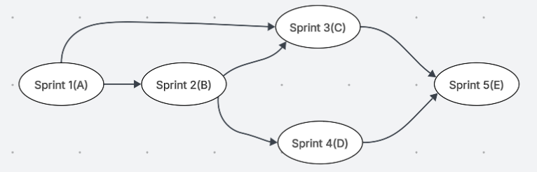

## This network diagram shows the sprints and their predicates. It shows the possible paths to complete this project, for instance, some of the paths that can be taken are ABCE and ABDE.

## **Appendix 4 Probability of Successful Completion**

The standard deviation and variance for each task:

Standard deviation =(P-O)/6

variance=((P-O)/6)2

- Where P is the estimated pessimistic activity time.

- Where the activity time estimate O is optimistic.

|  |  |  |  |  |  |
| --- | --- | --- | --- | --- | --- |
| Tasks | O (min) | M (most likely) | P (max) | Standard deviation | The variance |
| Task A | 4.5 | 6.5 | 9 | 0.75 | 0.56 |
| Task B | 5 | 8 | 13 | 1.33 | 1.77 |
| Task C | 6 | 8 | 10 | 0.66 | 0.44 |
| Task D | 6 | 7 | 11 | 0.83 | 0.69 |
| Task E | 5 | 6.5 | 8 | 0.5 | 0.25 |

Variance and Standard Deviations of Each Path:

|  |  |  |  |
| --- | --- | --- | --- |
| Paths | Variance for each task | Total variance for each path | Total standard deviation for each path |
| ACE | 0.56+0.44+0.25 | 1.25 | 1.12 |
| ABDE | 0.56+1.77+0.69+0.25 | 3.28 | 1.81 |
| ABCE | 0.56+1.77+0.44+0.25 | 3.03 | 1.74 |

Probability of successful completion:

Let's say D=30, which is the specified time, E is the expected time and $σ$ is the standard deviation

Z-Values= $\frac{D-E}{σ}$

|  |  |  |  |  |  |
| --- | --- | --- | --- | --- | --- |
| Paths | D | Total expected time | Path standard deviation | z-Values | Probability of finishing |
| ACE | 30 | 21.08 | 1.12 | 7.96 | 100% |
| ABDE | 30 | 28.92 | 1.81 | 0.6 | 72.57% |
| ABCE | 30 | 29.42 C.P. | 1.74 | 0.33 | 63% |

To sum up those are the probability of finishing the project 30 in days.

## **Appendix 5 Crashing approach**

|  |  |  |  |  |  |  |
| --- | --- | --- | --- | --- | --- | --- |
| Activity | Crashing Time (weeks) | Normal Time (weeks) | Normal Cost (USD) | Crash Cost (USD) | Max no. of days to reduction | Reduce Cost Per week (USD) |
| Task A | 5 | 6.5 | 1,781 | 2,137 | 1.5 | 237.33 |
| Task B | 7 | 8 | 1,902 | 2,283 | 1 | 381 |
| Task C | 6 | 8 | 1,781 | 2,137 | 2 | 178 |
| Task D | 5 | 7 | 1,902 | 2,283 | 2 | 190.5 |
| Task E | 6 | 6.5 | 2,009 | 2,411 | 0.5 | 804 |
| Total | 29 | 36 | 9,375 | 11,251 | 7 | 1790.83 |

Reduce Cost Per Day = (Crash Cost – Normal Cost) / (Normal Time – Crashing Time)

Let say we want to reduce the project finish time by 4.5 weeks:

C: 2 weeks*178= 356 (first cheapest)

B: 1 weeks *381= 381 (second cheapest)

A: 1.5 weeks*237.33= 356 (third cheapest)

356+ 356 +381=1,093

Total cost of crashing is 1,093

The new Total Normal Cost that will be paid: 9,375 + 1,093 = 10,468

## **Appendix 6 Project Management Diagrams**

### A6.1 Affinity Diagram

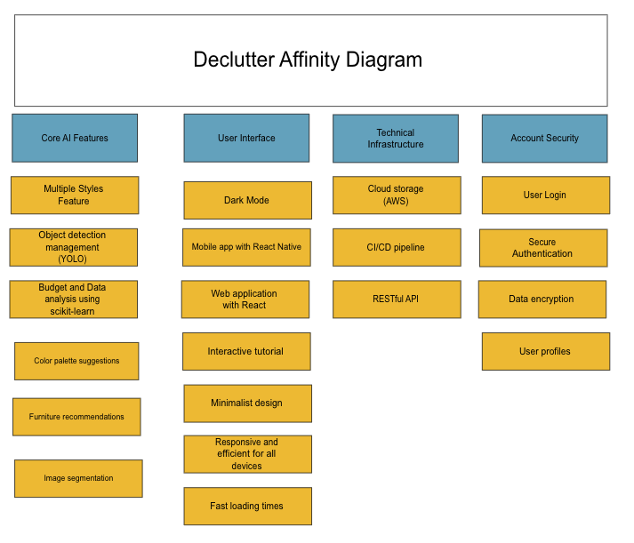This Affinity diagram shows Declutter’s product features. The core AI features include YOLO and data analysis using scikit-learn as well as colour palette suggestions. The UI includes dark mode and has a mobile app version built with React native. Declutter’s technical infrastructure is hosted on AWS cloud storage and has a CI/CD pipeline. The account security section consists of user login, secure authentication, data encryption and user profiles.

### A6.2 QFD Diagram

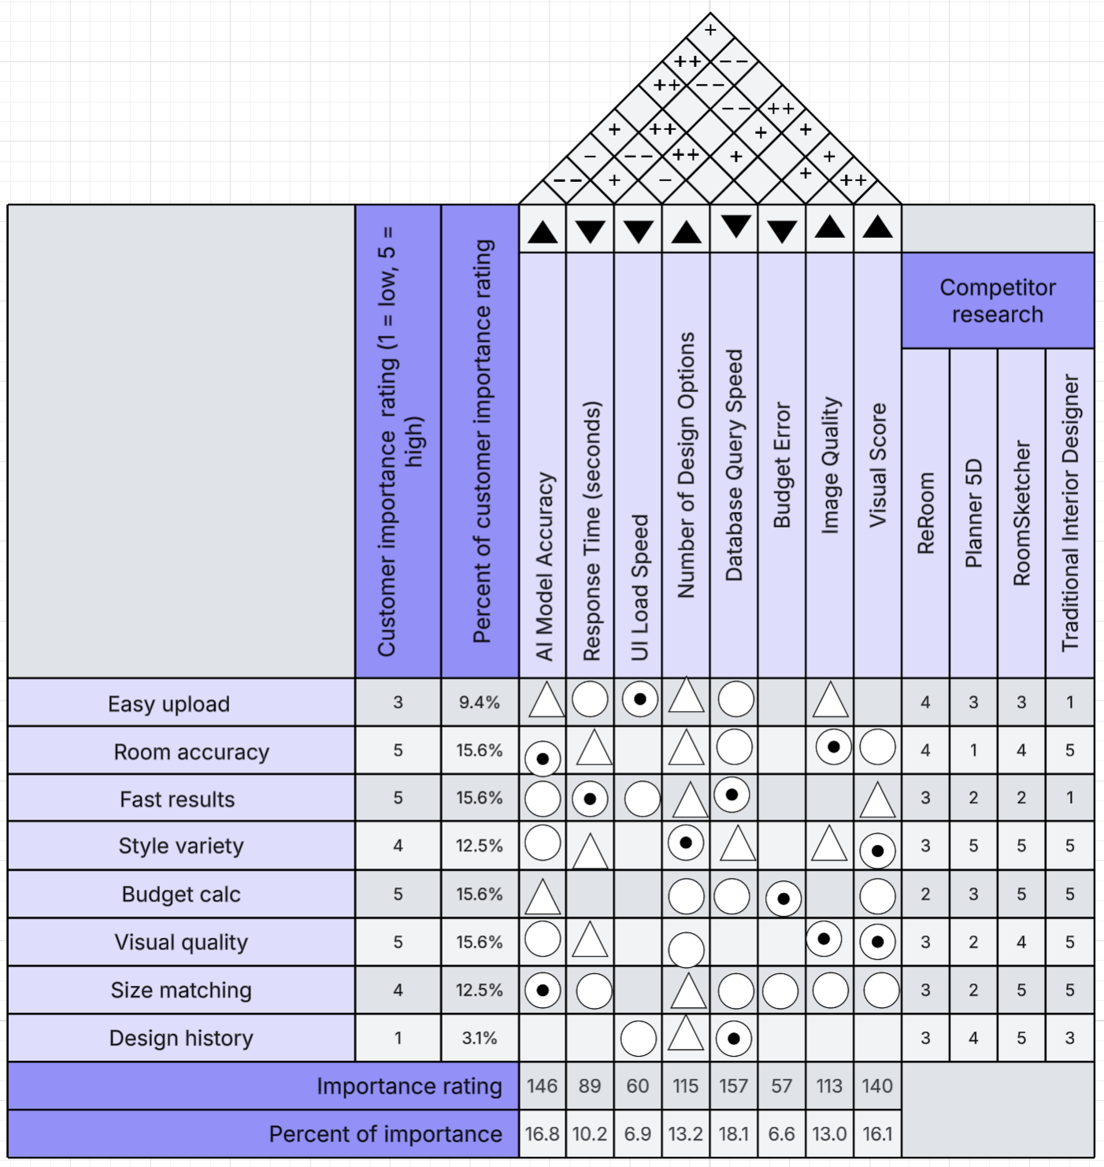

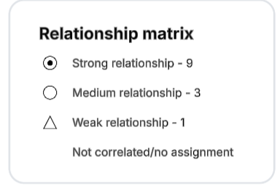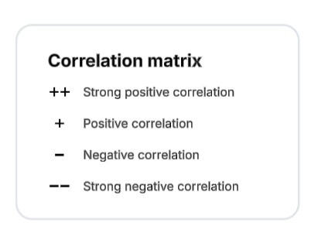

This quality functional deployment matrix analyses customer requirements (Easy upload, room accuracy etc...) x product requirements (AI model accuracy, UI Load speed etc...). The relationship symbols show the correlation between the requirements and how strongly they support each other. Customer Importance ratings for competitors are also shown for comparison. The roof represents the correlation between product requirements.

### A6.3 Pareto Chart

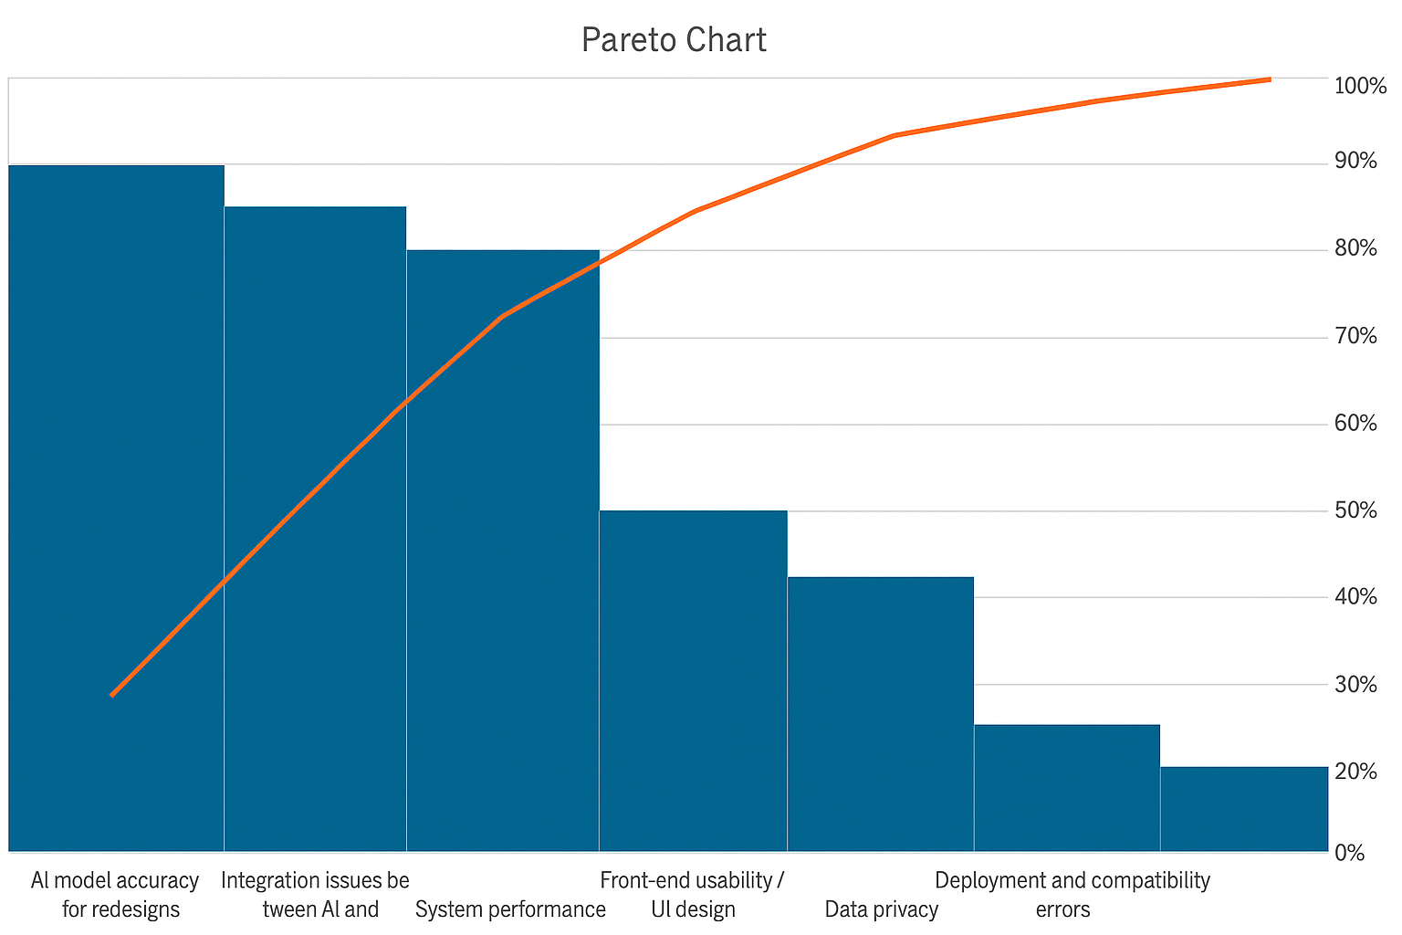

This Pareto Chart illustrates the primary issues affecting the project, highlighting that a small number of causes contribute to most problems: the 80/20% rule. The most significant issue is AI model accuracy for redesigns, followed closely by integration issues between the AI and back-end systems and system performance. Together, these three factors account for roughly 70–80% of the total impact, indicating they are the most critical areas to address. Other factors, such as front-end usability/UI design, data privacy, deployment and compatibility errors, and low user adoption or feedback, have comparatively smaller effects. According to the Pareto principle, focusing improvement efforts on the top three issues will likely yield the greatest overall enhancement in system quality and user satisfaction.

### A6.4 Kano Model

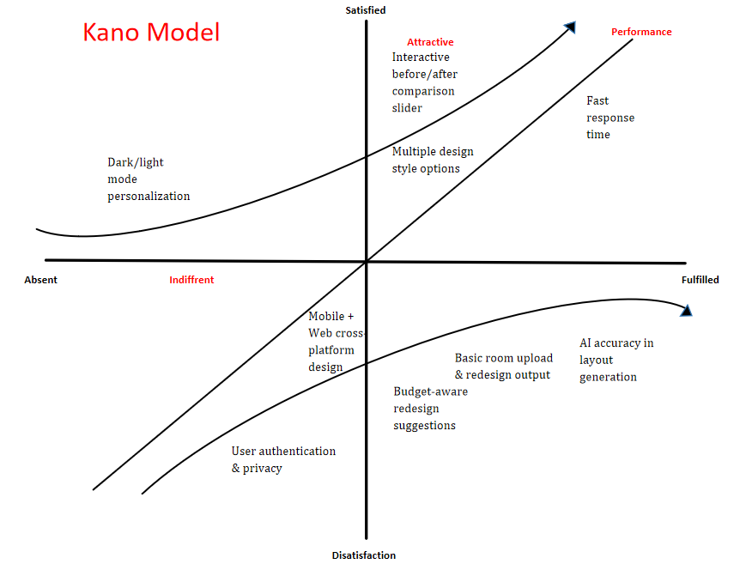The Kano Model diagram illustrates how different features of the project influence user satisfaction based on their presence or absence. It categorizes the features into basic, performance, and attractive attributes. The basic features such as user authentication, privacy, and budget-aware redesign suggestions are essential expectations. If missing, they cause dissatisfaction. Performance features, including AI accuracy in layout generation, and fast response time, have a direct linear relationship with satisfaction. The better they perform, the more satisfied users become. Attractive features like the interactive before-and-after comparison slider and multiple design style options are benefits that significantly boost user satisfaction when present but do not cause dissatisfaction when absent. Overall, the model suggests that focusing on improving performance and adding attractive features while maintaining basic functionality will lead to the highest user satisfaction and engagement.

### A6.5 Process Map

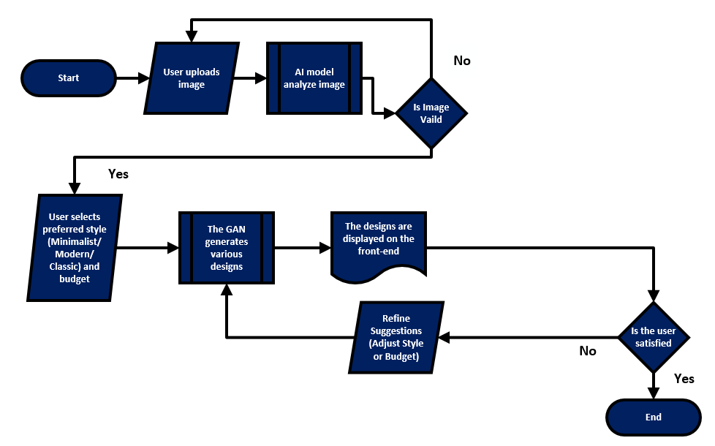138999 The Process map illustrates the processes that guide the users from uploading an image to receiving and refining design suggestions. The process begins when the user uploads an image, which is then analysed by the AI model to assess its validity. If the image is not valid, the system prompts the user to re-upload; if valid, the process continues. Next, the user selects their preferred style—such as minimalist, modern, or classic—and specifies a budget. Based on these inputs, a Generative Adversarial Network (GAN) generates multiple design options. These designs are then displayed on the front end for user review. If the user is not satisfied with the initial results, they can refine the suggestions by adjusting style preferences or budget constraints, prompting the GAN to regenerate new designs. This iterative loop continues until the user is satisfied with the output, at which point the process ends successfully. Overall, the diagram clearly represents a user-centric, iterative design workflow where AI continuously adapts to user preferences to deliver optimal home redesign results.

**A6.6 Fishbone Diagram**

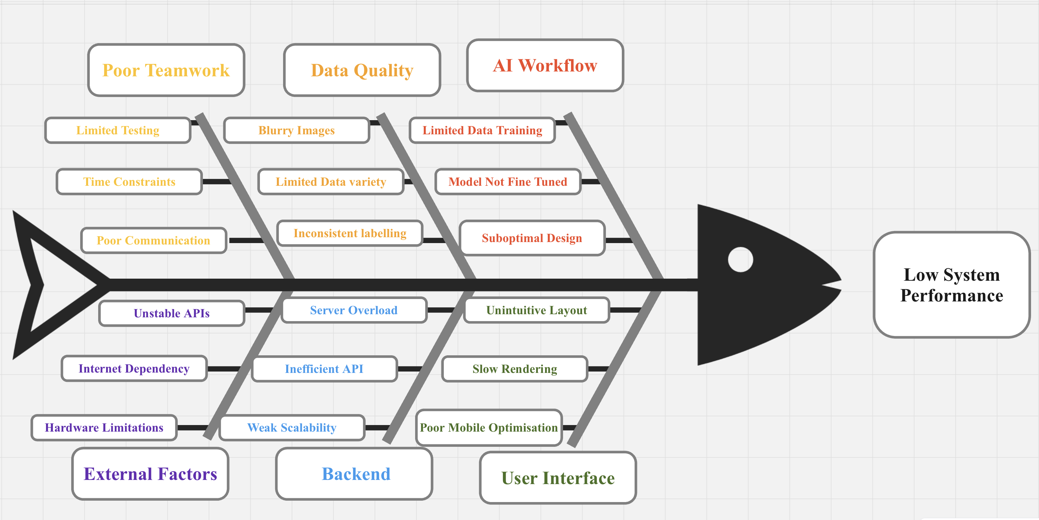

The fishbone diagram shown above describes the main roadblock that our project could face during its implementation and deployment: low system performance. It also illustrates the subproblems leading to the main issue, along with the smaller units that lead to each subproblem. The main subproblems we’ve outlined for our AI-powered minimalist interior design system are low quality of images, unfriendly user interface, server-side holdups, poor design of the AI workflow, lack of proper chemistry between the team members, as well as other external factors.

**A6.7 SWOT Analysis**

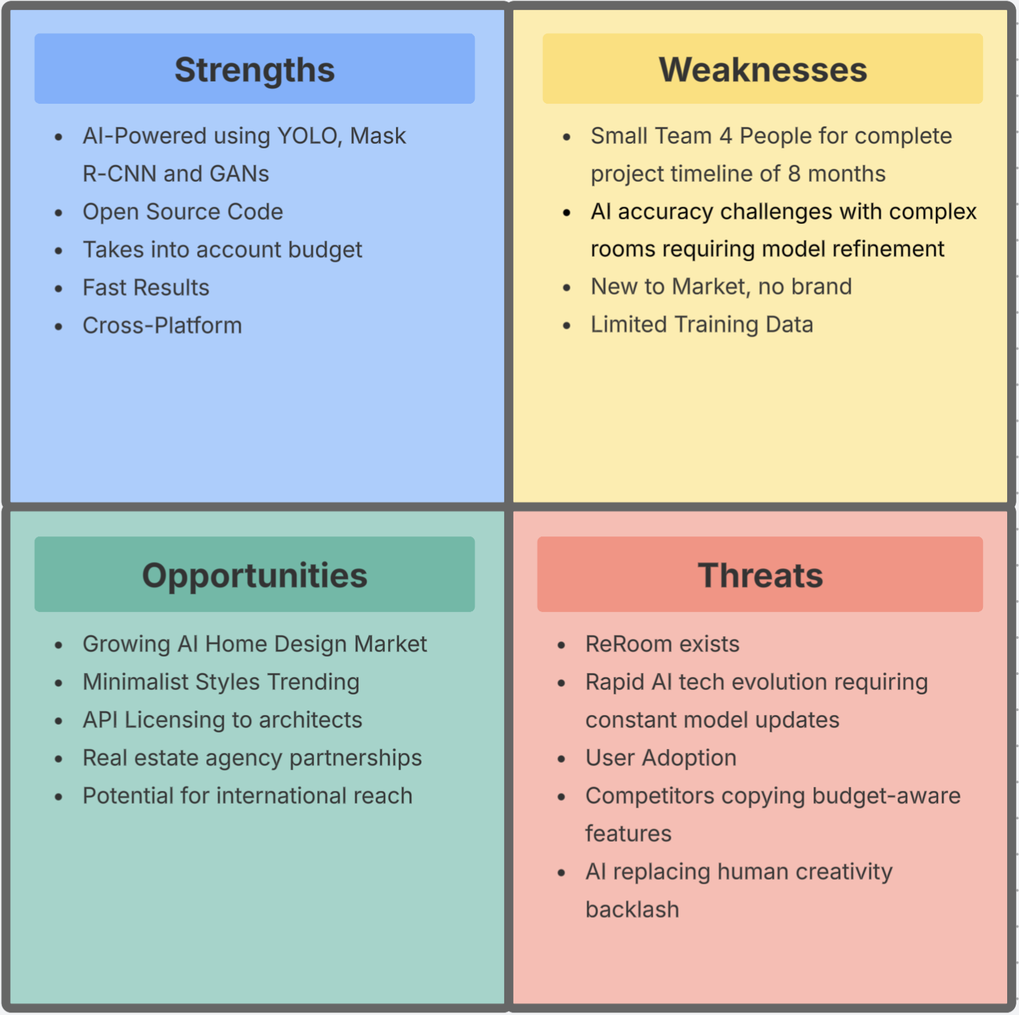

This SWOT Analysis evaluates the strengths, weaknesses, opportunities, and threats for Declutter. This project uses modern AI technologies including YOLO and Mask R-CNN, has an open-source code and is cross-platform. It also has several opportunities through the growing AI home design market and an increase in minimalist design. However, this project has a small team of 4 members and several AI accuracy challenges. There is also the threat of competitors through ReRoom and rapid AI evolution making this project require constant updates.

**A6.8 HR Plan**

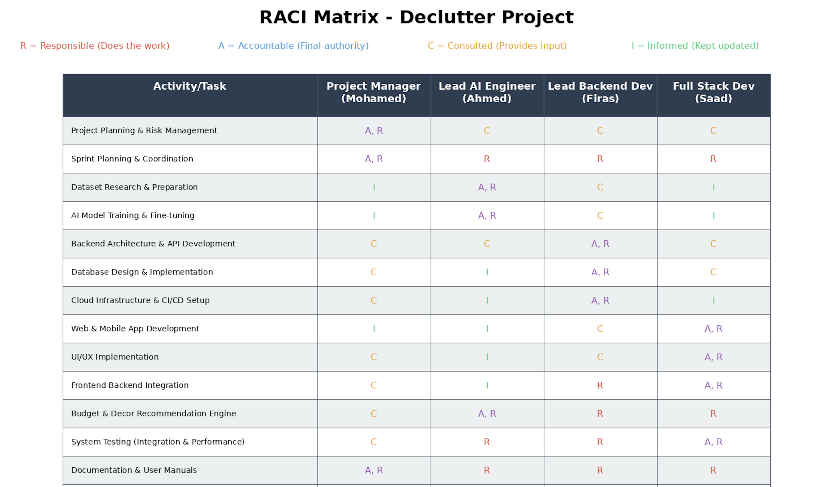

This HR Plan is shown by a RACI Matrix. Each member has specific roles for the given activities, for instance, in project planning and risk management Mohamed is Accountable and Responsible, whereas Saad, Firas and Ahmed are consulted. This format is shown for all the other activities including UI/UX Implementation and frontend-backend integration.